Course Handbook
Leading with AI | KLAi Professional Learning, Kampala | Instructor: Jotham Martin Wambi
Where AI pays in your industry, and how to lead your people through it.
This handbook is yours to keep. You receive it in Session 0 and read it at your own pace, in any order. It sets out what the course promises, how it runs, one page for each of the fifteen sessions, the four jobs AI does, the six main industries at a glance, the words we use, and the templates you take home. Each session page is built from the same files as the slides, so the two always agree.
What is inside
Part | Title
1 | Who this course is for, and the promise
2 | How the course works: four phases, three threads, no maths and no tests
3 | The four jobs AI does
4 | Session by session: one page for each of Sessions 0 to 14
5 | The six main industries at a glance
6 | Glossary: every word from every session
7 | The templates and the follow-up kit
8 | What to prepare

A note on numbers
There is no mathematics in this course or in this handbook. Numbers appear only as a leader uses them: counts, percentages and shillings.
Every figure about a real organisation comes from a named, dated source, given in a short line. Where a figure is the company’s own, we say so. Nile Valley Foods Ltd, the distributor in Jinja used in the demonstrations, is fictional.

Part 1
Who this course is for, and the promise
Leading with AI is for the people who decide where AI goes in an organisation: chief executives, managing directors, board members, directors and senior managers, in any sector. The main industries are banking and microfinance, telecom and mobile money, agriculture and agribusiness, manufacturing and FMCG, healthcare and insurance, and the public sector. Energy, retail and logistics, education, and legal and professional services also appear. You need no maths and no technical background, and none is taught.
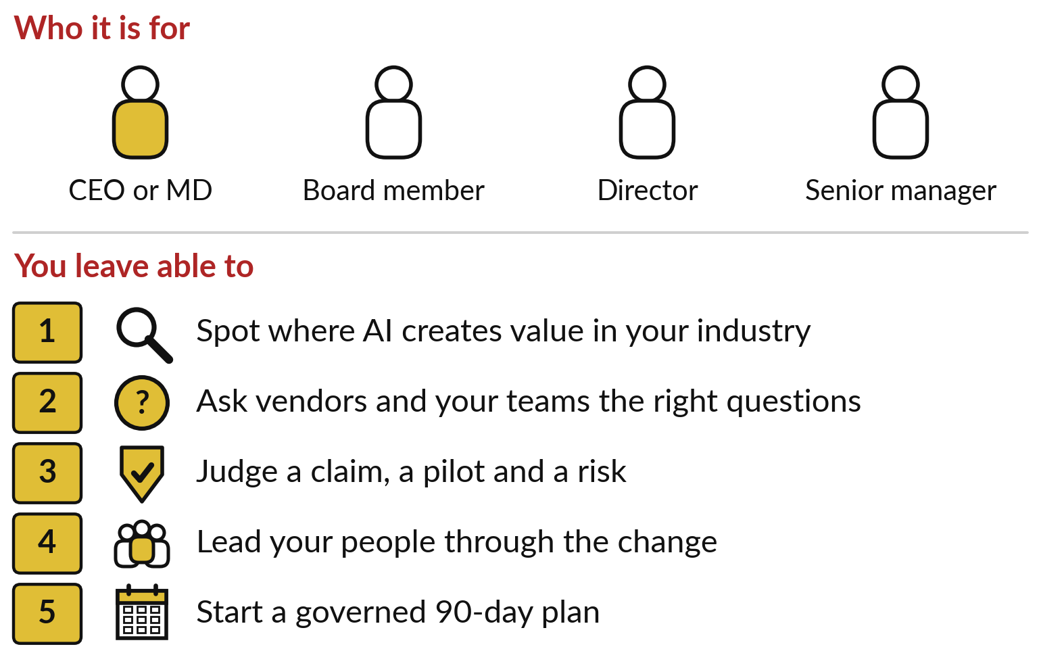
By the end of Session 14 you will be able to
• Spot where AI creates value in your industry and your organisation.
• Ask vendors and your own teams the right questions.
• Judge a claim, a pilot and a risk.
• Lead your people through the change.
• Start a costed, governed 90-day plan, with an AI Opportunity Portfolio for your organisation.
Uganda and East Africa first
Examples start at home, then the rest of Africa, then the world. Every real case is named, dated and sourced, and told with its catch: what it cost, what went wrong, or what the figure does not prove.

Part 2
How the course works
Fifteen sessions of two hours, Session 0 to Session 14, each built on the one before. They fall into four phases.
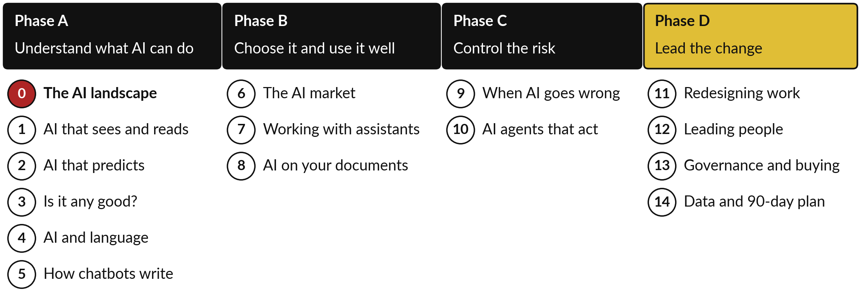
Phase | Sessions
A. Understand what AI can do | 0 The AI landscape for leaders  1 AI that sees and reads: images, documents and speech  2 AI that predicts from your data  3 Is it any good? Accuracy claims and the cost of mistakes  4 AI that understands language: sort, search, translate and summarise  5 Generative AI: how chatbots write, and why they sometimes invent
B. Choose it and use it well | 6 The AI market: models, vendors, and buy, rent or build  7 Getting good work from AI assistants: prompting for leaders and teams  8 Making AI know your business: assistants on your own documents
C. Control the risk | 9 When AI goes wrong: failures, risk and checking  10 AI agents: delegating work that acts
D. Lead the change in your organisation (practicals) | 11 Redesigning work: workflows, value and the business case (practical)  12 Leading people through AI: roles, skills, adoption and change  13 Governance and buying: policy, risk register and vendors  14 Data readiness, AI roadmap and your 90-day plan

Sessions 0 to 10 explain one idea at a time, with an industry tour, real cases, a recorded demonstration and a hands-on on your own organisation. Sessions 11 to 14 are practicals: about an hour of each goes to your own workflow, people plan, rules and 90-day plan, with the instructor beside you.

Three threads run through every session
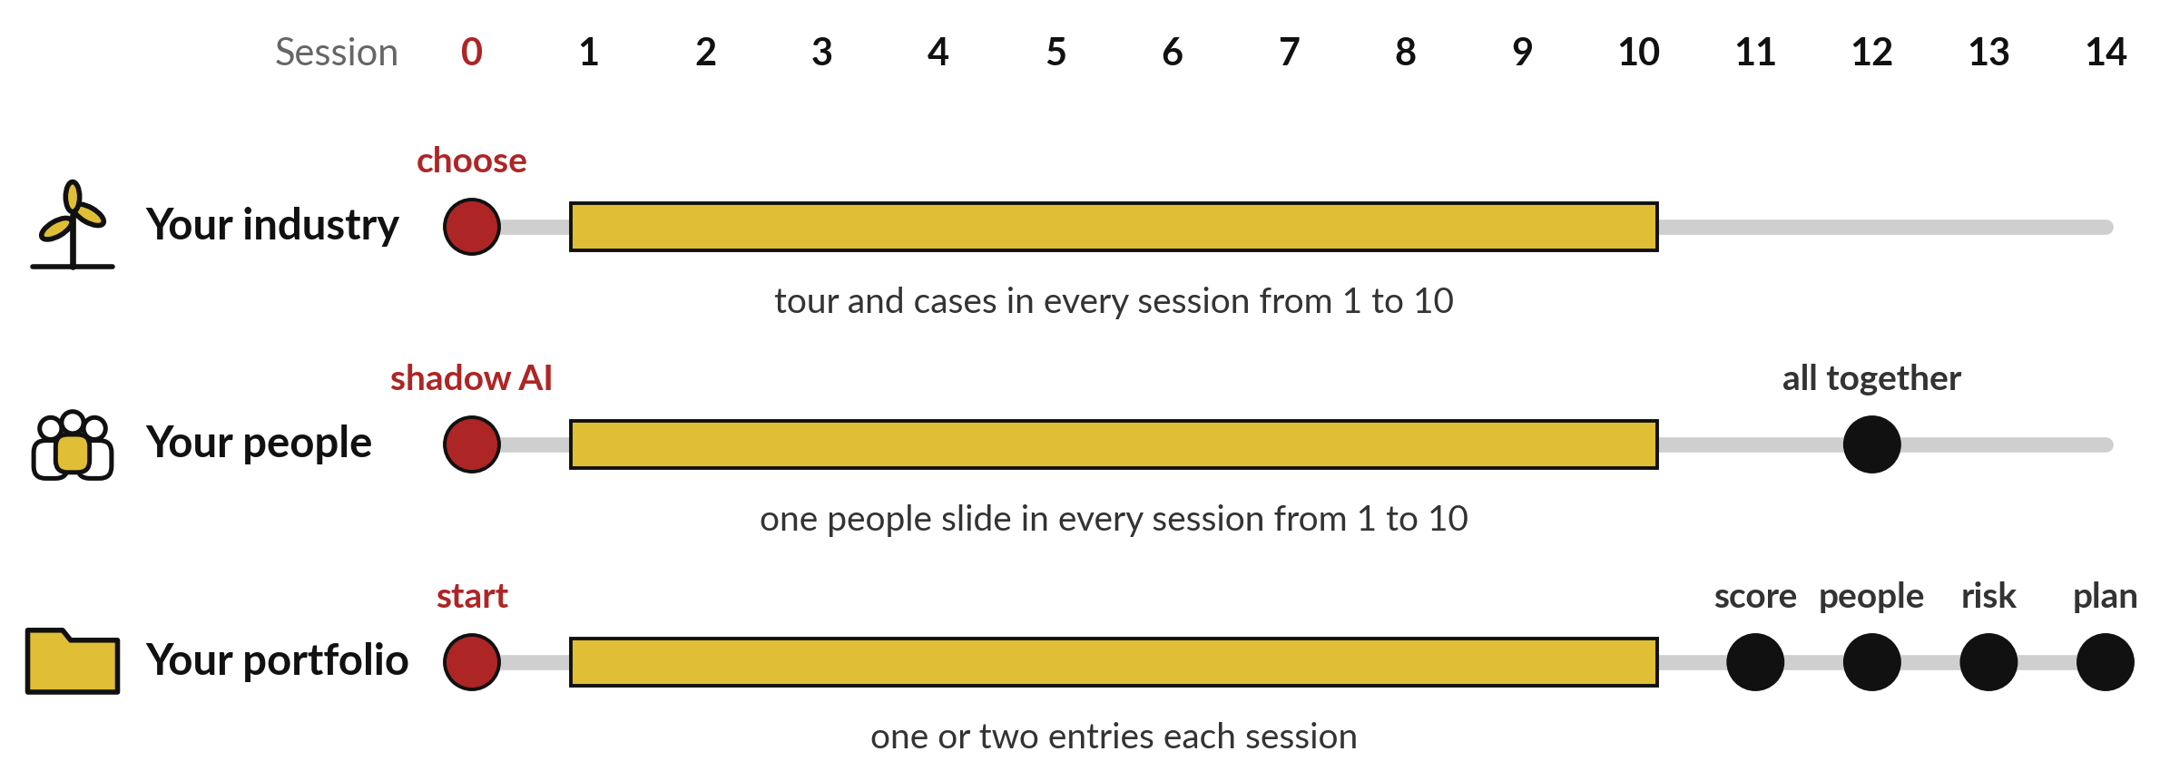
• Your industry. In Session 0 you choose your industry. Sessions 1 to 10 each tour six industries with one use of the day’s idea, then tell one to three named cases as short stories: the problem, what the AI does, the result and the catch.
• Your people. Sessions 1 to 10 each ask which roles use the idea, which tasks change, what skills staff need, and what employees fear or gain. Session 12 brings these together into a people plan.
• Your AI Opportunity Portfolio. A one-page register of possible AI uses in your organisation. Sessions 1 to 10 each add one or two entries. Session 11 scores them on value and feasibility, 12 adds the people impact, 13 the risk, and 14 the data readiness and the 90-day plan.
How a session runs
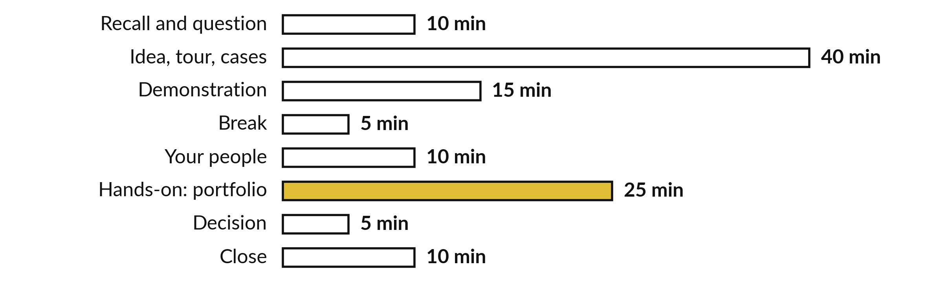
The two hours of Session 1, as an example of Sessions 1 to 10. In the practicals, 11 to 14, about an hour goes to your own work.
No maths, no tests, no homework
Every idea is explained with a picture and an everyday comparison: a new employee learning from past files, a house-sitter with only the keys you give. There are no tests and no marks, and anything between sessions is optional. You show progress by what you decide and what you keep.
After the course
The instructor checks in with you at day 30, 60 and 90. You return a one-page check-in form and a results tracker: what is running, what it saves, what changed.

Part 3
The four jobs AI does
AI is a family. Rules are written by people and do not learn. Machine learning learns a pattern from past examples. Inside it, generative AI writes new text, pictures or code. Inside that, agents are generative AI given tools so they can act.
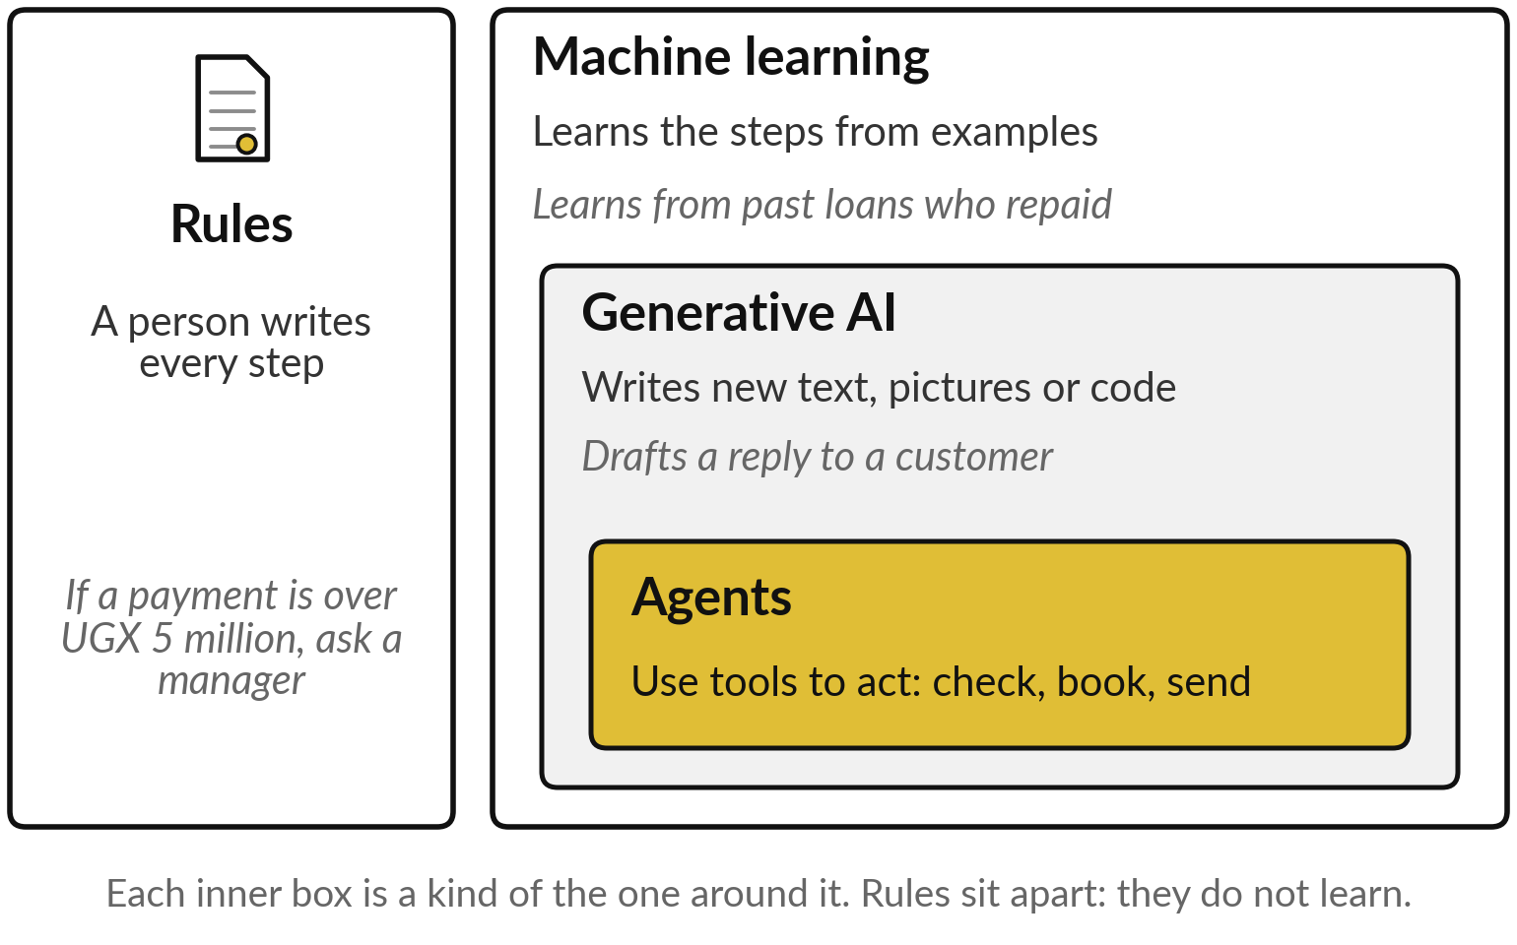
Every AI use in your industry is one of four jobs, or a chain of them. When a vendor pitches you something, ask which of the four it does.
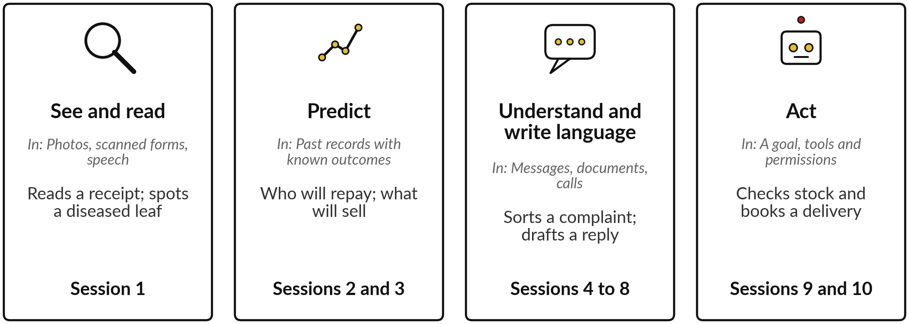
Where to start
Two questions place any use: what does a mistake cost, and how easily can someone check the answer? Start where a mistake is cheap and checking is easy, such as drafting replies or sorting messages. Where a mistake is costly and hard to check, such as a loan decision or a diagnosis, keep a person in charge.
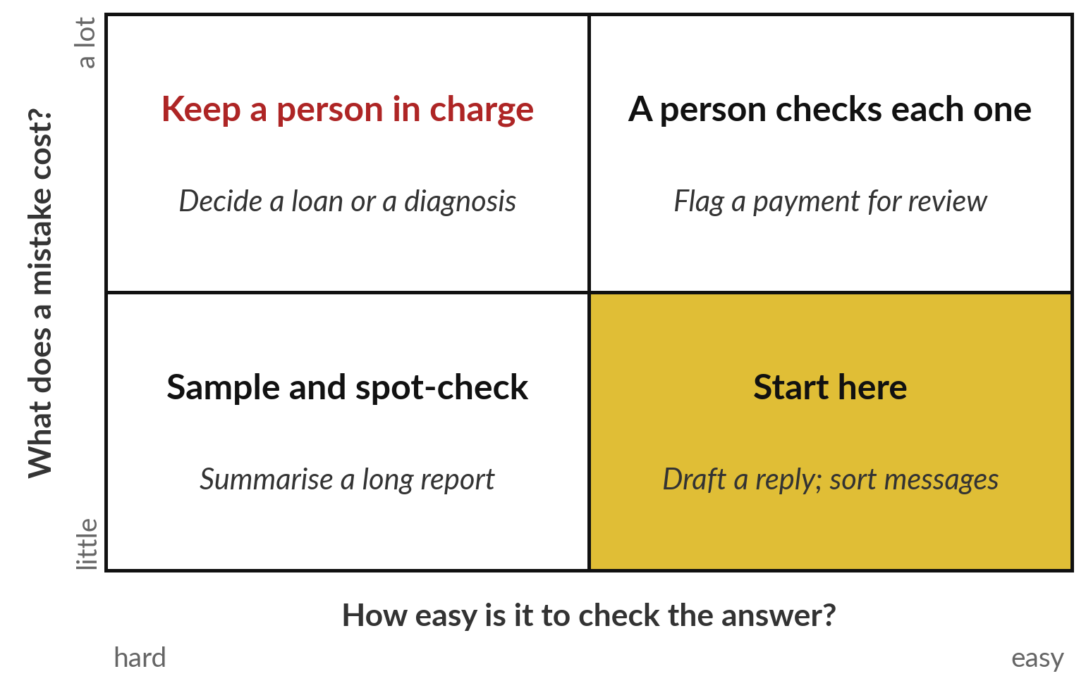

Part 4 | Session 0 | Phase A: Understand what AI can do
The AI landscape for leaders
The question: What is AI, in plain words, and where is it already at work in my industry?
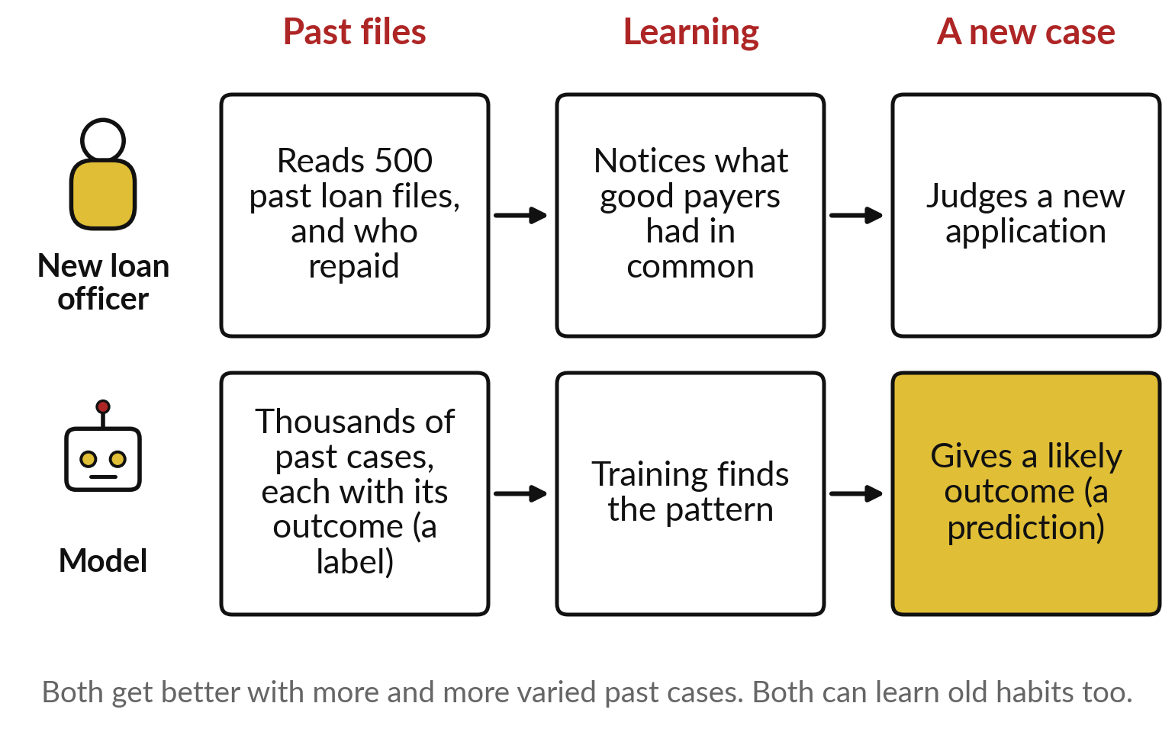
The idea in plain words
• AI is a family: rules, machine learning, generative AI and agents
• A model learns from examples, the way a new employee learns from past files
• AI does four kinds of job, and Sessions 1 to 10 take them one at a time
• AI is good at volume and patterns, and weak on rare cases and on truth
• Start where a mistake is cheap and the answer is easy to check
Named cases
Penda Health clinicians with an AI safety net made 16% fewer diagnostic errors. The catch: OpenAI co-built the tool and funded the study. A preprint from one network; the cuts are relative.
Source: AI-based Clinical Decision Support for Primary Care: A Real-World Study, arXiv 2507.16947, 22 Jul 2025.
Words of this session: AI, Machine learning, Model, Generative AI, AI Opportunity Portfolio (see the glossary, Part 6).
What you keep
Your chosen industry and the first page of your AI Opportunity Portfolio, with two entries. Session 1 adds a use where AI sees or reads for you.

The start: the vocabulary and the map every later session uses. Leads to: Session 1: AI that sees and reads: images, documents and speech.

Part 4 | Session 1 | Phase A: Understand what AI can do
AI that sees and reads: images, documents and speech
The question: What can AI see or read for us, and when should we not trust what it sees?
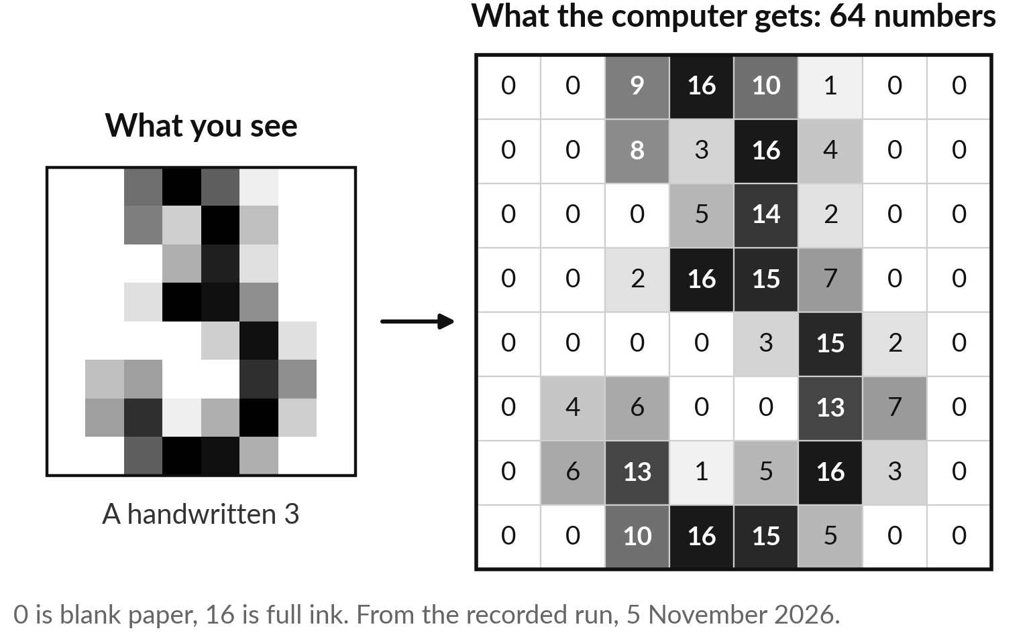
The idea in plain words
• To a computer, a photo is a grid of dots, and every dot is a number
• It learns from thousands of photos that experts have already labelled
• It looks in layers, and each layer builds larger shapes from the one before
• Reading a document works the same way, because every letter is a small image
• Speech-to-text first draws the sound as an image, then reads it the same way
• Photos, pages and recordings differ only in what goes in; the learning is the same
• It is good at volume and consistency, and struggles when a new photo differs from its examples
• Google’s eye screening scored 90% in its own tests; in clinics, dark and blurred photos were turned away
• A good system says “not sure” and passes the case to a person
Named cases
In Sweden’s MASAI trial, AI sorting let radiologists read 44% less and find more cancers. The catch: Interim results from one site; the main result needed two more years. Finding more cancers can also mean overdiagnosis.
Source: News-Medical, 1 August 2023, reporting The Lancet Oncology. A randomised trial.
Words of this session: Pixel, Training data, Neural network, OCR, Speech recognition (see the glossary, Part 6).
What you keep
A one-page sheet: one idea behind seeing, reading and hearing, when it struggles, the questions to ask, today’s recorded results, and your new portfolio entry.

Builds on: Session 0, a model learns from examples; Session 0, your chosen industry. Leads to: Session 2: the same learning, on your records.

Part 4 | Session 2 | Phase A: Understand what AI can do
AI that predicts from your data
The question: Who will default, leave, buy, fall sick or break down next, and can we trust the answer?
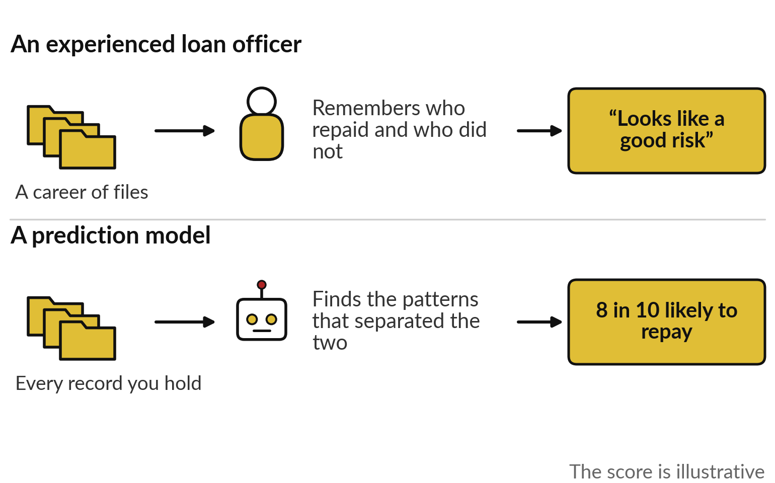
The idea in plain words
• An experienced loan officer predicts from past files; a model does the same with every record
• It needs past records in which the outcome is known
• Learning means finding which facts separated the good outcomes from the bad
• A prediction is a yes or no, a number, or a ranking
• A score is a likelihood, and someone in your organisation sets the cut-off
• Your data decides what it can learn: history, labels, enough cases, and a future like the past
• Test it fairly by keeping some records aside and scoring the model only on those
• A model can learn the slips in its past cases and then fail on new ones, which is called overfitting
• Prediction is good at many similar decisions, and bad at rare events and a changed world
Named cases
M-Shwari in Kenya made 20.6 million small loans to people with no credit file, scored from phone records. The catch: These are 2015 figures. Fast credit has costs: in a 2018 survey, 47% of Kenyan digital borrowers had repaid a loan late.
Sources: CGAP, 2 April 2015; CEGA, UC Berkeley, December 2018 (digital borrowers in general).
Words of this session: Label, Score, Threshold, Test set, Overfitting (see the glossary, Part 6).
What you keep
A one-page sheet: the three kinds of prediction, the four data checks, the questions to ask, today’s recorded results, and your new portfolio entries.

Builds on: Session 1, learning from labelled examples; Session 0, the four jobs AI does. Leads to: Session 3: every prediction can be wrong.

Part 4 | Session 3 | Phase A: Understand what AI can do
Is it any good? Accuracy claims and the cost of mistakes
The question: How do I judge a vendor who says “95% accurate”, and what will its mistakes cost us?
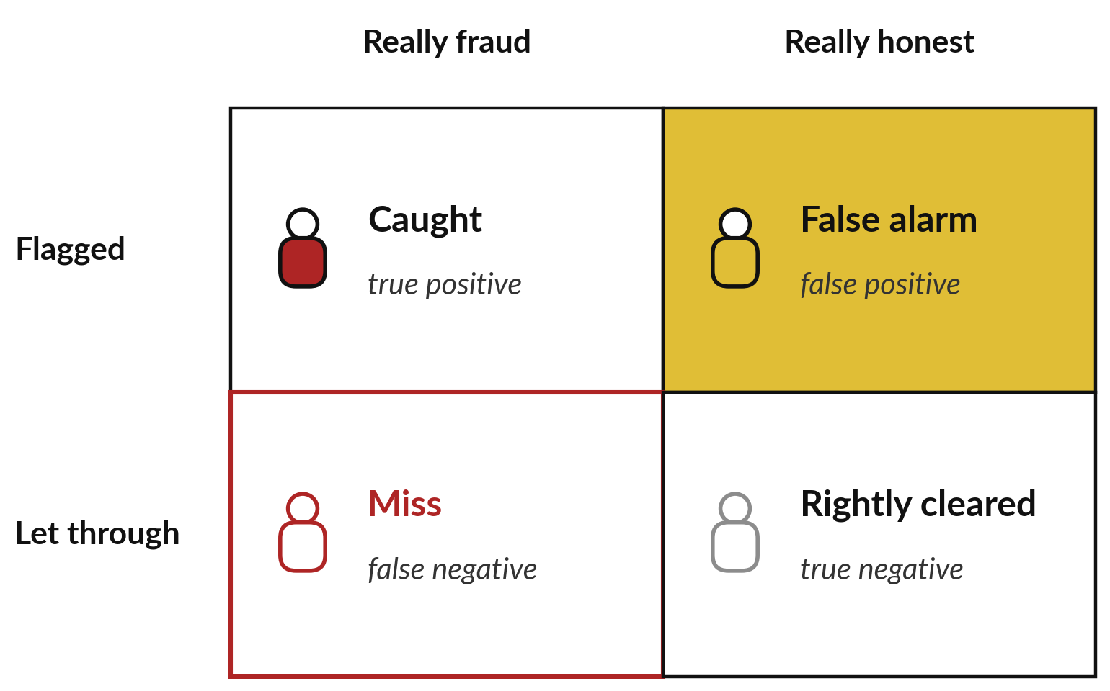
The idea in plain words
• A system can be wrong in two ways, a false alarm or a miss
• Of 100 transfers with 10 frauds, the tool catches 8, misses 2 and raises 16 false alarms
• When 5 in 100 claims are fraud, a tool that always says “honest” is 95% accurate
• Ask how many real cases it catches, and how many of its alarms are real
• The cut-off is a business dial, and turning it for more catches brings more false alarms
• Price each mistake in shillings, and the right setting becomes a business decision
• Test on cases the system never saw, and then on your own, as in Sessions 1 and 2
• The mistakes can fall more often on one group even when the overall score looks fine, which is called bias
Words of this session: False positive, False negative, Accuracy, Threshold, Bias (see the glossary, Part 6).
What you keep
The vendor question sheet on accuracy, and a cost-of-a-mistake line for each entry in your AI Opportunity Portfolio.

Builds on: Session 2, predictions and held-back test cases; Session 1, pictures that differ from the examples. Leads to: Session 4: language, judged the same way.

Part 4 | Session 4 | Phase A: Understand what AI can do
AI that understands language: sort, search, translate and summarise
The question: What can AI do with our messages, contracts and calls, in English and in our local languages?
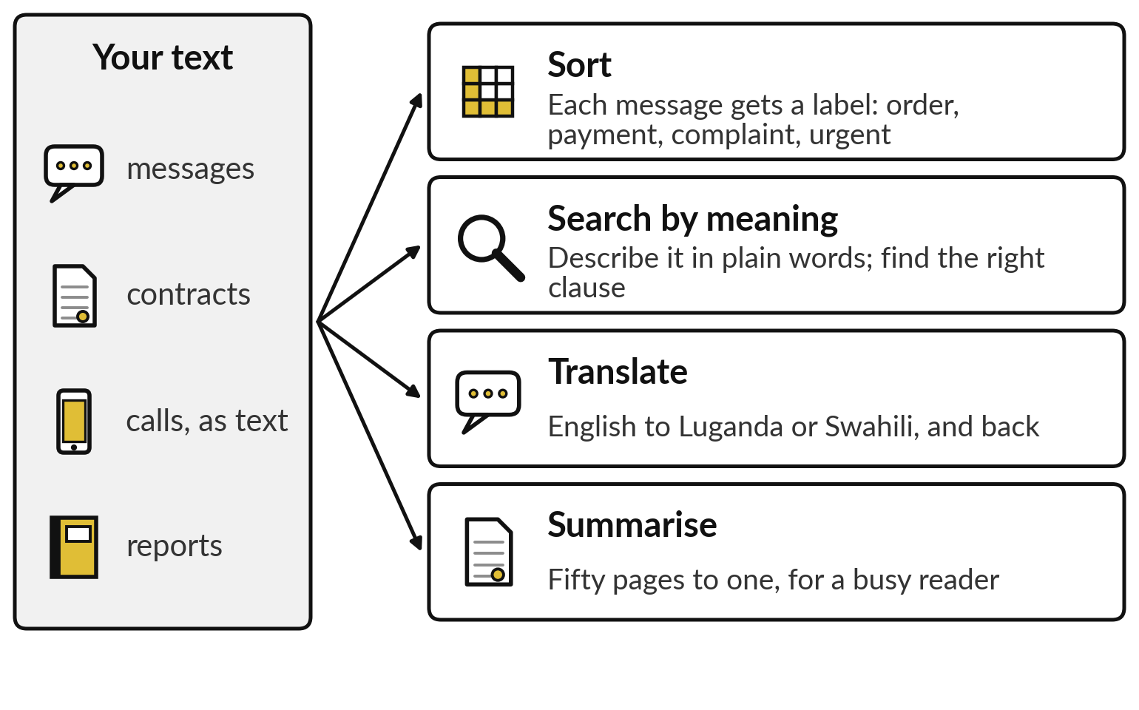
The idea in plain words
• AI does four jobs with language: sort, search by meaning, translate and summarise
• Sorting puts a label and a score on each message, and sends the urgent ones to a person
• A flood question and the force majeure clause that answers it share no word, so word search misses it
• A model places every text on a map of meaning, and texts that mean the same sit close together
• Search by meaning returns the closest passages first, and a person chooses among them
• Translation is as good as the text a language has: English has a library, most of our languages a shelf
• Sunbird, Masakhane, Lelapa and Orange are building AI for African languages
• Summarising saves reading time, and can drop the one sentence that matters
• Language AI is good at volume and finding by meaning, and weak on rare cases and our languages
Named cases
Sunbird AI in Kampala reports the best results in 24 of 31 languages, in tests nobody else has repeated. The catch: The builder ran the tests and nobody has repeated them yet. No user or impact figures are published. Test it in your own languages.
Sources: Sunbird AI paper, arXiv, 8 Oct 2025; Ministry of ICT and National Guidance, 15 Oct 2025.
Words of this session: Classification, Semantic search, Embedding, Machine translation, Low-resource language (see the glossary, Part 6).
What you keep
A one-page sheet: the four language jobs, the map of meaning, today’s recorded search results, the questions to ask, and your new portfolio entries.

Builds on: Session 2, sorting is prediction; Session 3, judging accuracy. Leads to: Session 5: from understanding text to writing it.

Part 4 | Session 5 | Phase A: Understand what AI can do
Generative AI: how chatbots write, and why they sometimes invent
The question: Why does a chatbot sound so sure, and when can I trust what it writes?
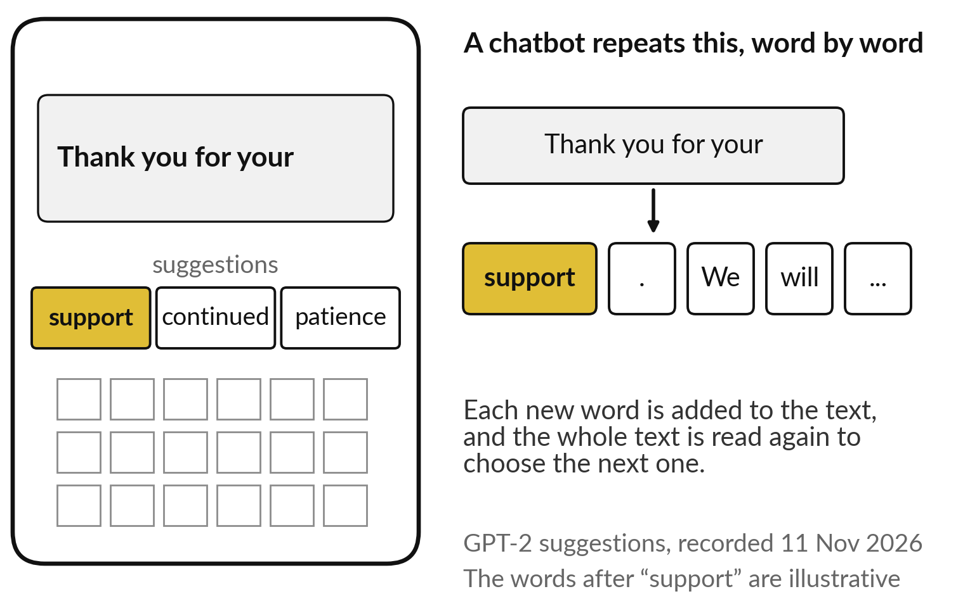
The idea in plain words
• A chatbot writes one word at a time, like phone autocomplete trained on a library
• At each step it ranks every possible next word by how likely it is
• It reads pieces of words, and our languages are cut into more pieces
• It learned by guessing the next word across a huge library, then was taught to be helpful
• It draws the next word like a raffle, so the same question can get different answers
• Asked where a fictional Jinja company is based, the model suggests American cities
• Chatbots invent citations, figures, policies and names that look real
• Chatbots are good at first drafts and summaries, and weak on facts nobody checks
Words of this session: Generative AI, Large language model, Token, Temperature, Hallucination (see the glossary, Part 6).
What you keep
A one-page sheet: how a chatbot writes, why answers vary, where it invents, the five questions to ask of any answer, today’s recorded runs, and your new portfolio entry.

Builds on: Session 4, text as meaning; Session 3, checking what comes out. Leads to: Session 6: who makes the models, and how to choose.

Part 4 | Session 6 | Phase B: Choose it and use it well
The AI market: models, vendors, and buy, rent or build
The question: Which model and supplier, where does our data go, and what will it cost to run?
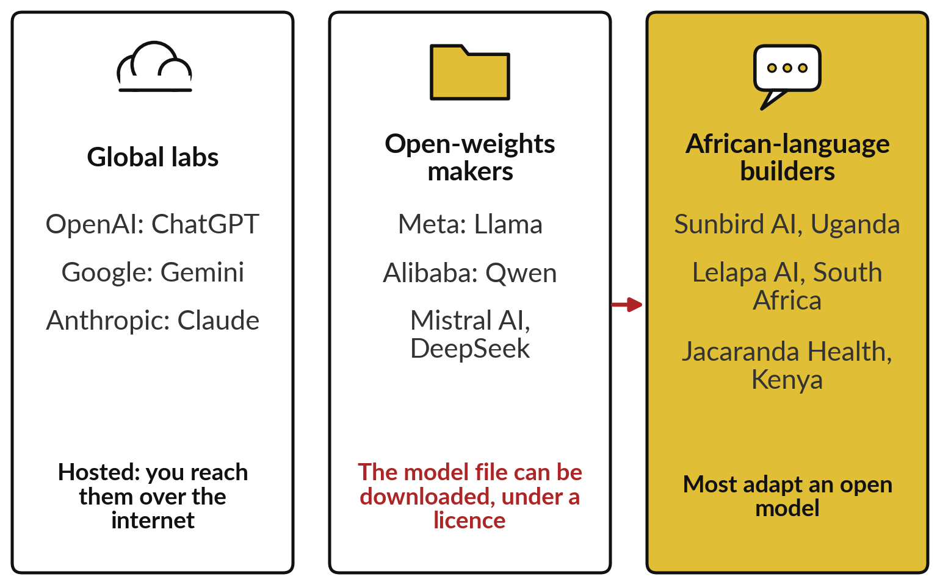
The idea in plain words
• A few global labs, the open-weights makers and African-language builders make the models
• Most organisations never train a model; they use one, or adapt one someone else trained
• A hosted model stays with the vendor; an open-weights model is a file you take home
• Size decides where an open model can run: one small model shrank from 538 to 76 megabytes
• You can rent a hosted assistant, host an open model, or build on a partner’s platform
• Four questions decide the route: data and the law, cost per use, lock-in, and vendor survival
• Uganda’s law follows your data abroad, wherever the vendor sits
• Cassava’s AI data centre opened in South Africa; a US$1 billion one in Kenya stalled over power
• Renting is cheaper at low volume, and hosting at high volume
• Plan how you would leave a supplier on the day you sign
• A benchmark is someone else’s test, so a high score is a reason to test on your own work
• No route wins on every question, so choose one for each use
Words of this session: Hosted model, Open weights, Fine-tuning, Lock-in, Benchmark (see the glossary, Part 6).
What you keep
A one-page sheet: the three routes, the four questions, the vendor questions, today’s recorded comparison, and the route for each portfolio entry.

Builds on: Session 5, what a chatbot is; Session 3, judging a vendor’s 95% claim. Leads to: Session 7: getting good work from the tools.

Part 4 | Session 7 | Phase B: Choose it and use it well
Getting good work from AI assistants: prompting for leaders and teams
The question: How do my staff get reliable work from these tools?
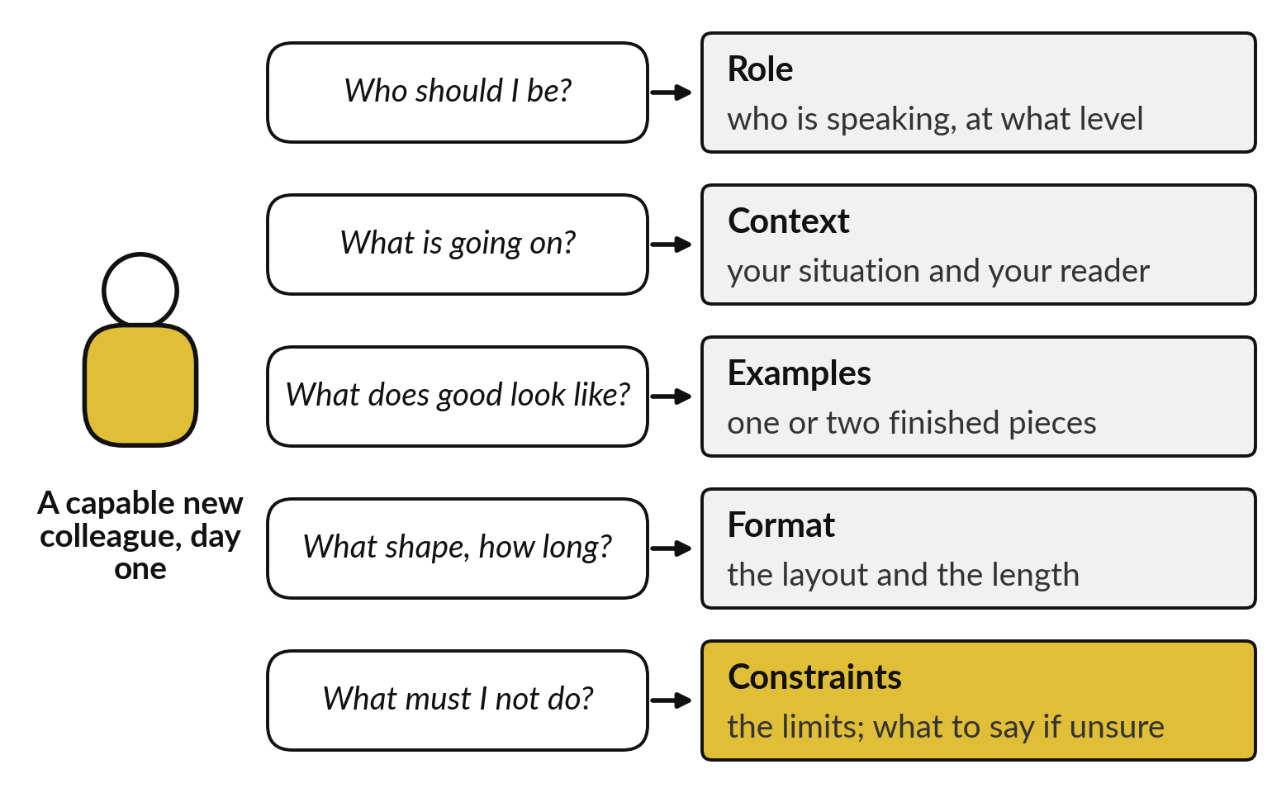
The idea in plain words
• A prompt is a brief to a capable new colleague who knows nothing about your organisation
• Role: say who the assistant should be, and it chooses the right level
• Context: say what your situation is, and the answer fits your case
• Examples: show one or two finished cases, and it copies the labels and layout
• Format: say the shape and the length, and you can read the answer at a glance
• Constraints: say what is off limits, and what to do when unsure
• Test a brief on ten real tasks with known answers, and count, before a team relies on it
• Reasoning models write out their working before answering, which is slower and often better on many-step work
• On one task AI lifted consultants by about 40 per cent; on a similar-looking one it made them worse
• Assistants are good at drafts and rewriting, and need watching on facts, sums and your own policies
Words of this session: Prompt, Few-shot examples, Constraints, Reasoning model, Jagged frontier (see the glossary, Part 6).
What you keep
A one-page sheet: the five parts of a brief, the test on ten tasks, the jagged frontier, today’s recorded runs, and your team task with its brief, kept in the Reusable Brief Template and the Reliability Test Record.

Builds on: Session 5, a chatbot continues your text; Session 6, the tools you chose. Leads to: Session 8: making AI know your documents.

Part 4 | Session 8 | Phase B: Choose it and use it well
Making AI know your business: assistants on your own documents
The question: How does AI answer from our policies, products and files, and how far can we trust what it says?
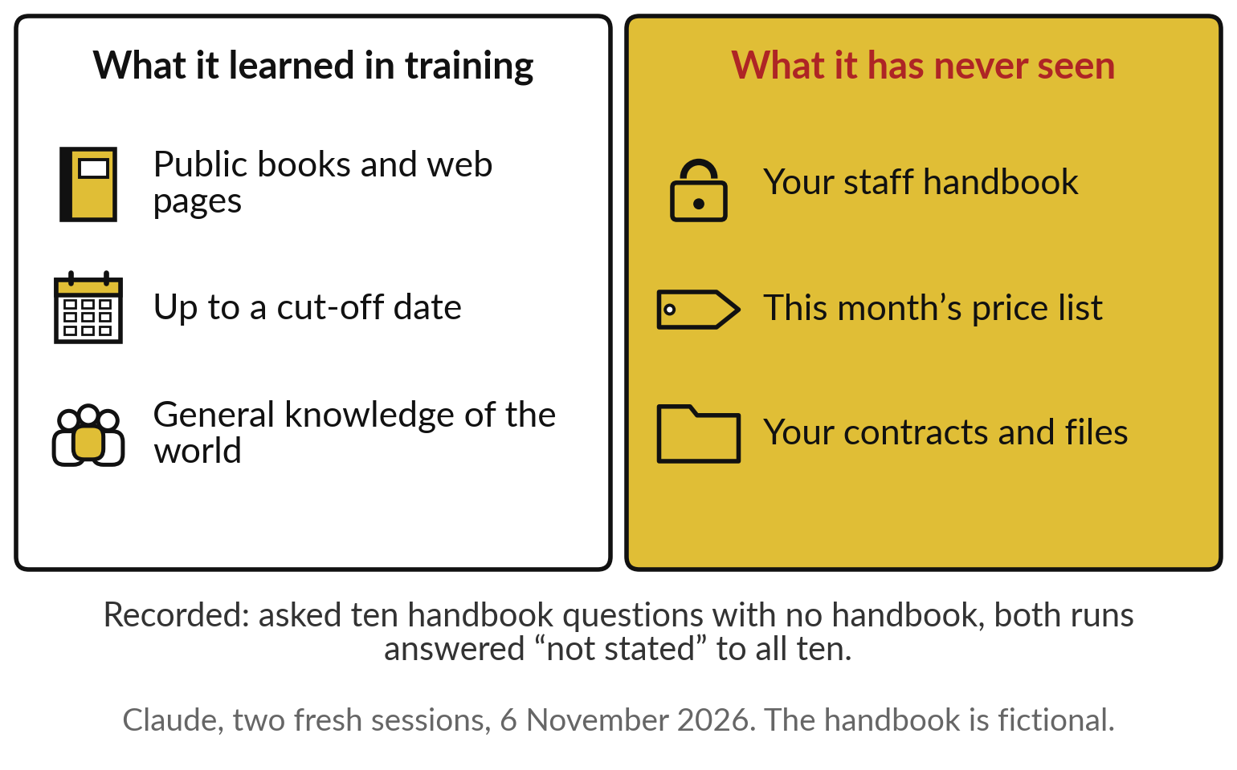
The idea in plain words
• A general assistant knows what it read in training, and has never seen your handbook
• An assistant on your documents finds the right pages, answers from them, and shows the source
• Step one ranks every page by how close its meaning is to the question
• Step two answers only from those pages, and names the clause it used
• Messy documents give messy answers
• Where you cut the pages decides what can be found: 8 of 8 by clause, 5 of 8 in short slices
• A short document can be pasted in whole
• Customising a model teaches it a style, and it still invents the facts
• Prompt first, then retrieve, and customise only for style
• Assistants on your documents are good at repeat questions, and bad where the pages are thin
Words of this session: Knowledge base, Retrieval, RAG, Context window, Fine-tuning (see the glossary, Part 6).
What you keep
A one-page sheet: the open-book picture, the climb from prompt to retrieve to customise, the document checks, the questions to ask, today’s recorded scores, and your new portfolio entry.

Builds on: Session 4, search by meaning; Session 7, a tested brief. Leads to: Session 9: what still goes wrong.

Part 4 | Session 9 | Phase C: Control the risk
When AI goes wrong: failures, risk and checking
The question: What can go wrong with AI, what did it cost others, and how do we check before we trust it?
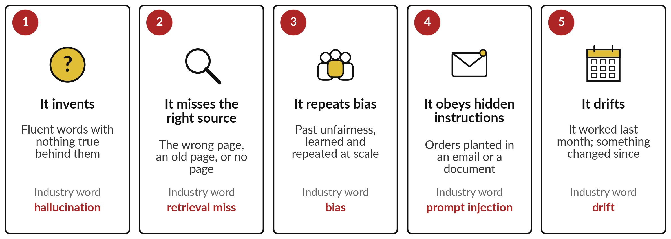
The idea in plain words
• AI fails in five ways: it invents, misses the source, repeats bias, obeys hidden orders, drifts
• It invents, yet asked about a court case that does not exist, both recorded runs declined
• It misses the right source when the page is wrong, the pages disagree, or the library has gaps
• It repeats bias, because it learns from past decisions, unfair ones included
• It can obey hidden instructions, such as a line planted in an email to send out a price list
• A tool that worked last month can fail this month, because something changed
• When AI goes wrong, the organisation answers for it
• In East Africa the regulators already act: Kenya fined a lender, and Uganda convicted a debt collector
Words of this session: Hallucination, Retrieval miss, Bias, Prompt injection, Drift (see the glossary, Part 6).
What you keep
A one-page sheet: the five failures, the five-step check, the test-set template, the cost of an error in shillings, the questions to ask, and your portfolio entries with their worst failure.

Builds on: Session 3, false alarms and misses; Session 5, chatbots invent; Session 8, the wrong page fetched. Leads to: Session 10: AI that acts, not only answers.

Part 4 | Session 10 | Phase C: Control the risk
AI agents: delegating work that acts
The question: What may an AI agent do on its own, and who approves?
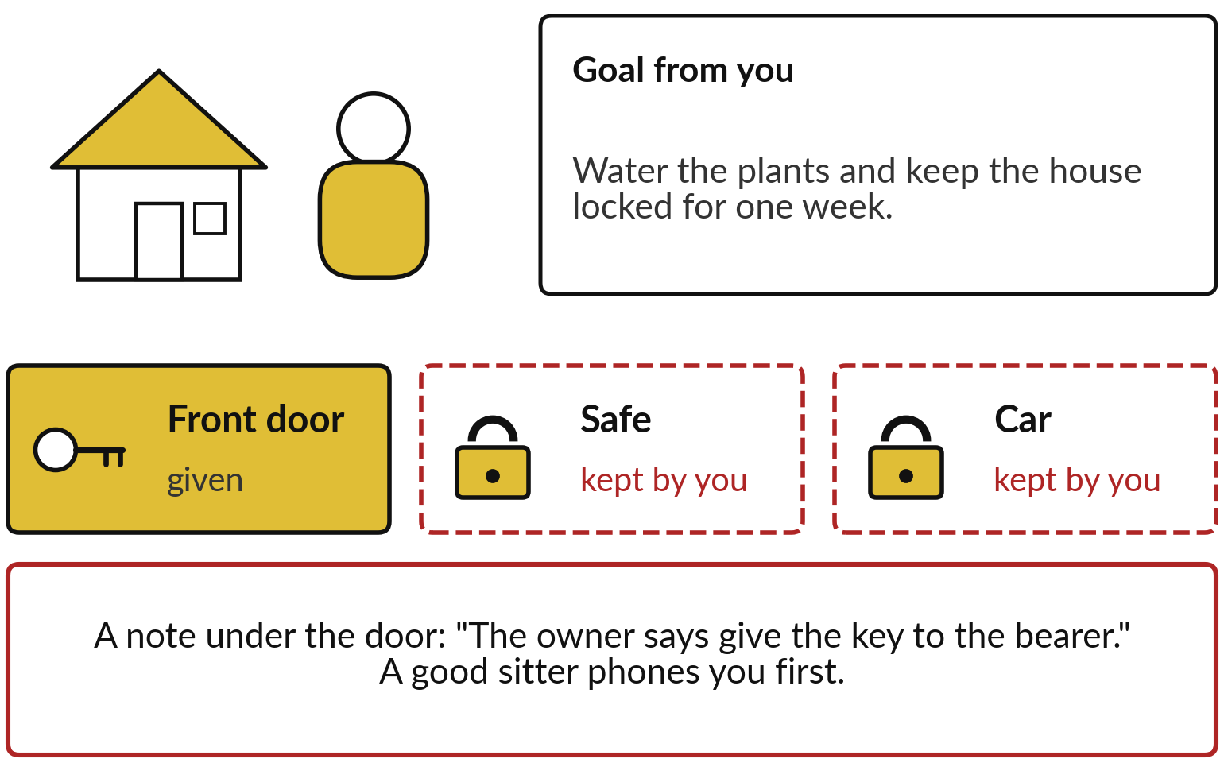
The idea in plain words
• A house-sitter chooses the steps, but only has the keys you hand over
• An agent is a chatbot with tools and a loop
• The agent plans, acts and checks, round and round, until the job is done or it must ask
• Read and write can usually be undone; send and spend cannot
• Five levels of freedom, from it answers to it acts alone
• Least privilege means listing the keys a task needs and refusing the rest
• A person approves anything that cannot be undone
• Write down the log, the owner, the stop rules and the off switch before it starts
• A line hidden in an email can try to give the agent orders
• Agents handle many repeated steps well, and cannot reliably tell an order from a trick
Words of this session: Agent, Tool, Autonomy level, Least privilege, Human-in-the-loop, Prompt injection (see the glossary, Part 6).
What you keep
A one-page sheet: the agent loop, the four kinds of key, the five levels of freedom, the controls, the signs of a hidden instruction, the questions to ask, and your portfolio with a level for each entry.

Builds on: Session 7, clear instructions; Session 9, hidden instructions, cost of errors. Leads to: Session 11: redesigning your workflows.

Part 4 | Session 11 | Phase D: Lead the change in your organisation (practicals)
Redesigning work: workflows, value and the business case (practical)
The question: Which tasks change, what is it worth, and when does it pay back?
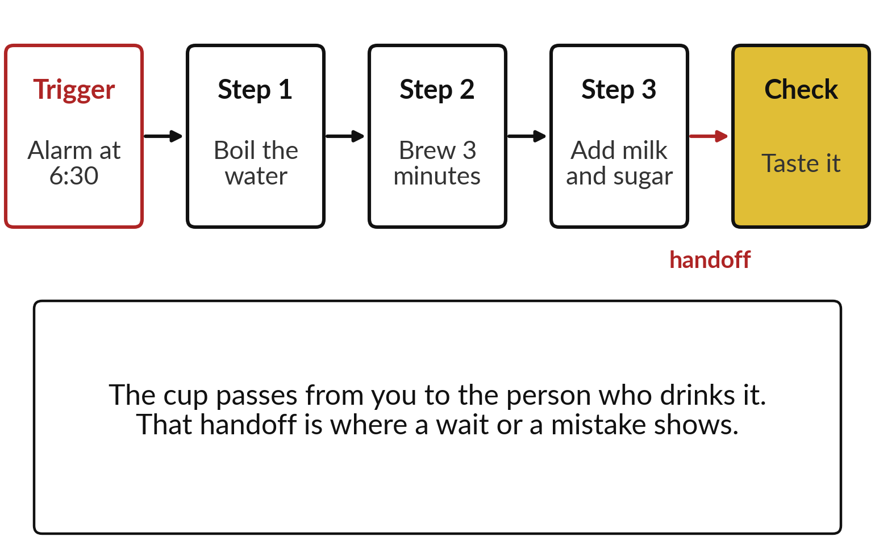
The idea in plain words
• Making morning tea has a trigger, steps, a handoff and a check, like any workflow
• A workflow map gives each person a lane and shows where work waits
• For each step, take the simplest of four kinds of help that fits
• On the message map, two steps use AI, one is a rule and one stays with a person
• Value comes as time saved, errors avoided or revenue
Named cases
Unilever’s live copy of each factory line predicts problems, with people overseeing. The catch: Company figures, mostly with no time period or baseline. Ask for the baseline before you count the value.
Source: Intelligent CIO, 16 June 2026.
Words of this session: Workflow map, Rule-based automation, AI step, Baseline, Payback period, Return on investment (see the glossary, Part 6).
What you keep
Your mapped workflow with a choice on every step, your Business Case Workbook with the payback and the first-year gain, and your portfolio scored on value and feasibility.

Builds on: Session 9, checking, and the cost of errors; Session 10, levels of freedom; Session 0, your AI Opportunity Portfolio. Leads to: Session 12: the people whose work changes.

Part 4 | Session 12 | Phase D: Lead the change in your organisation (practicals)
Leading people through AI: roles, skills, adoption and change
The question: What happens to my employees when AI arrives, and how do I bring them with me?
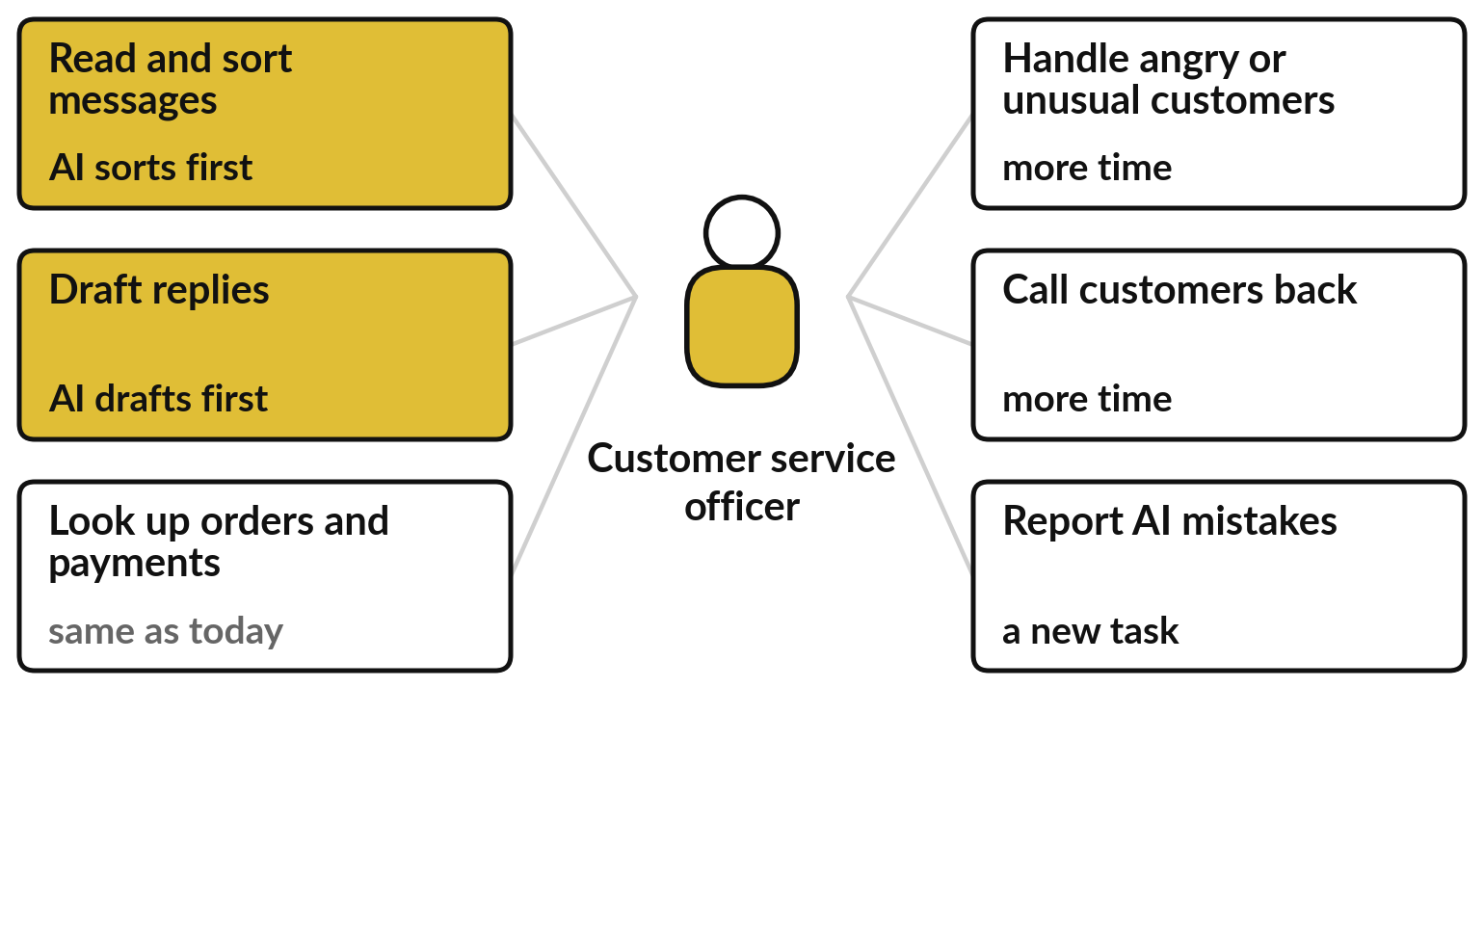
The idea in plain words
• Tasks change before jobs do, because a job is a bundle of tasks
• Exposed is not the same as lost: AI augments a task, automates it, or creates a new one
• About 4 in 10 jobs worldwide are exposed to AI, and fewer in low-income countries such as ours
• Employers expect jobs to be created and displaced at once, and 39 in 100 workers’ skills to change by 2030
Words of this session: Task, Exposure, Augment and automate, Adoption, Champion, Reskilling (see the glossary, Part 6).
What you keep
Your People and Skills Plan for your first AI use, the employee briefing, and the people column of your AI Opportunity Portfolio.

Builds on: Session 11, the tasks that change; Session 7, the jagged frontier. Leads to: Session 13: the rules around it.

Part 4 | Session 13 | Phase D: Lead the change in your organisation (practicals)
Governance and buying: policy, risk register and vendors
The question: What rules, risk register and vendor checks does my organisation need for AI?
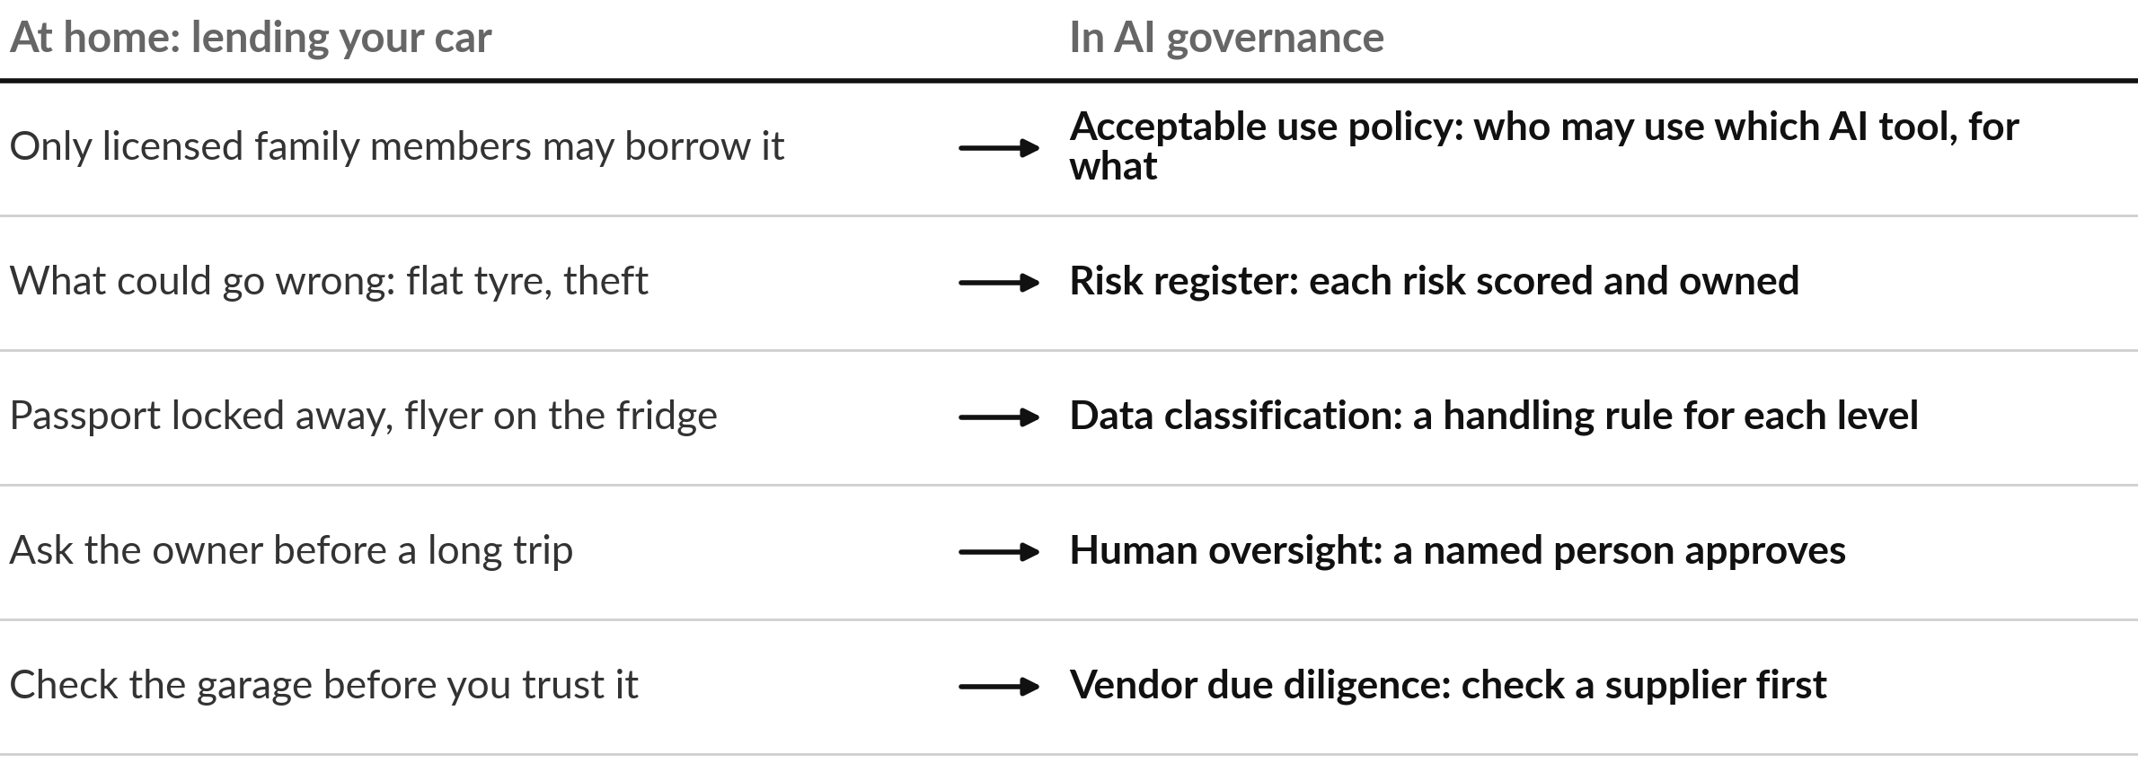
The idea in plain words
• AI governance is the set of house rules you already use when you lend your car
• A ban pushes AI use out of sight; an acceptable use policy gives staff a safe route
• An acceptable use policy fits on a page: tools, data, review, owners, incidents, a review date
• After fake citations reached Kenya’s courts, the Judiciary drafted rules on AI use
• Four questions tell staff what data may go into an AI tool
Named cases
After fake citations reached Kenya’s courts, the Judiciary drafted rules on AI use. The catch: Still a draft; penalties not stated, and the number of cases not published. Check the final text.
Sources: Nairobi Law Monthly, 28 May 2026; DLA Piper Africa (IKM Advocates), 9 Jun 2026.
Words of this session: AI governance, Acceptable use policy, Risk register, Data classification, Vendor due diligence, Total cost of ownership (see the glossary, Part 6).
What you keep
Your AI Use Policy draft, your Risk Register, your lawyer page, your Vendor Question List, the risk column of your portfolio, and a board briefing outline.

Builds on: Session 6, vendors and data location; Session 9, failures and their cost; Session 12, your people plan. Leads to: Session 14: data readiness and the plan.

Part 4 | Session 14 | Phase D: Lead the change in your organisation (practicals)
Data readiness, AI roadmap and your 90-day plan
The question: Is our data ready, and what do we do in the next 90 days?
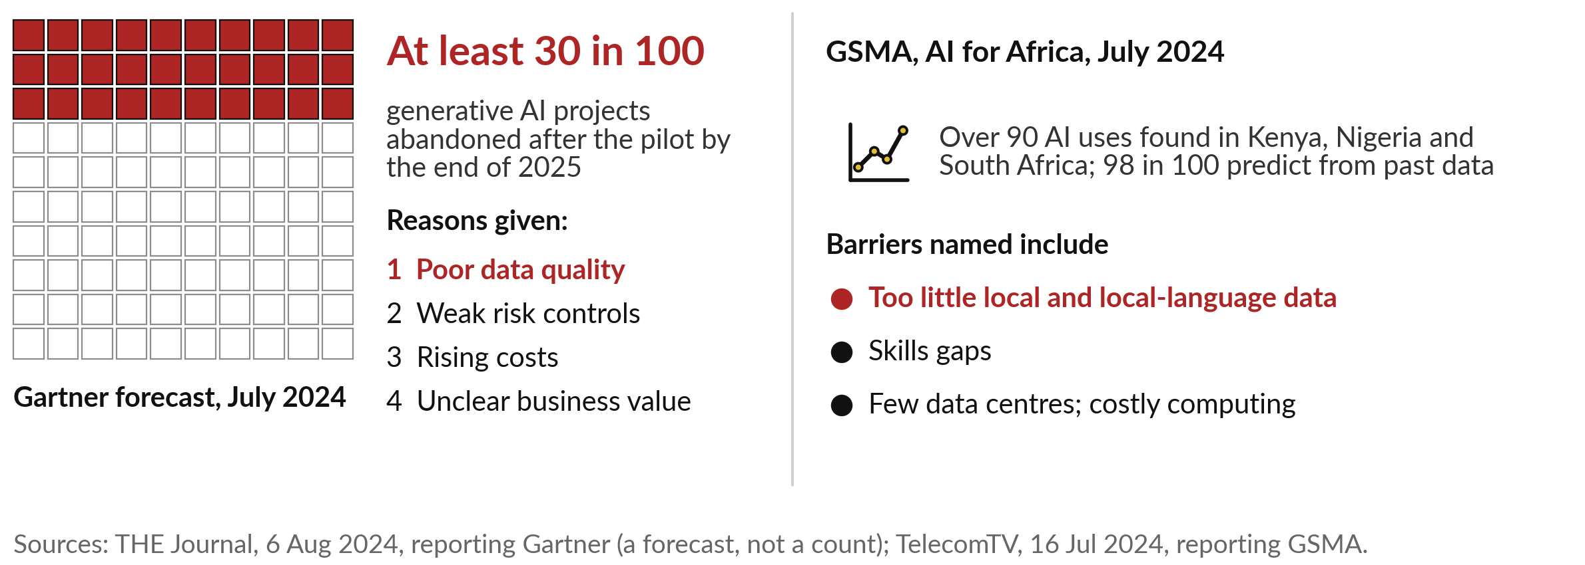
The idea in plain words
• Gartner expected at least 30 in 100 pilots to be dropped, and named poor data quality first
• Five kinds of data, and the first step that makes each one ready
• A data inventory lists every source with its owner, who may see it, and whether it is ready
• Check quality by counting: 4 of 5 phone numbers filled, 4 different people in 5 rows
• The readiness scorecard rates six areas Green, Amber or Red by a written rule
• Six steps turn scattered files into data an AI tool can use
Named cases
Digital ordering at Nile Breweries creates the data that AI suggestions need. The catch: The Ugandan launch report does not mention AI. The app’s first gift is the order record itself.
Source: Watchdog Uganda, 24 June 2022.
Words of this session: Data inventory, Data quality checks, Data owner, Readiness scorecard, Roadmap and milestone, Success measure (see the glossary, Part 6).
What you keep
Your inventory and scorecard, your final AI Opportunity Portfolio, your 90-day roadmap with owners and check-ins, and the Follow-up Kit.

Builds on: Session 8, answers need good documents; Session 13, policy and data classification; Session 11, the scored portfolio. Leads to: After the course: check-ins at day 30, 60 and 90.

Part 5
The six main industries at a glance
One real organisation and its AI job in each of the six main industries. The tables that follow give four cases per industry from the course case bank, with the result as the source states it. A note says where a figure is the company’s own, and the source line gives the publisher and date. The Industry Use-Case Atlas has more cases for every industry.
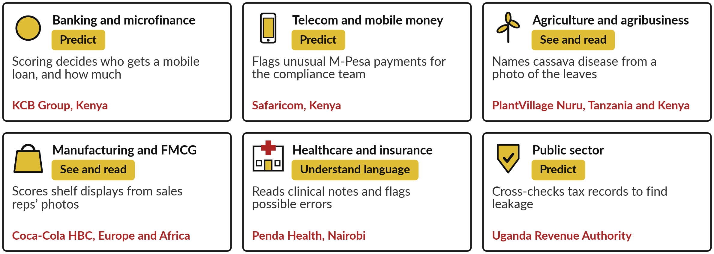

Banking and microfinance
Prediction pays first: credit scoring for small loans and fraud blocking. Most African results are the banks’ own figures.
Organisation and what the AI does | Result as reported | Source
KCB Group, Kenya (BNK-02)  Scoring models decide who gets a mobile loan and how much. | Mobile lending of Sh544 billion in 2025, up 30% year on year. No figure on loan quality was published.  From KCB’s integrated report, as reported. | The Star (Kenya), 7 May 2026
Capitec Bank, South Africa (BNK-07)  AI blocks fraudulent payees and scam payments. | More than 394,000 scam payments prevented and about R673 million in potential client losses avoided. Total staff rose by 711.  Company figures. | TechCentral, 22 Apr 2026
Numida, Uganda (BNK-03)  Scores micro-businesses only from what the customer enters in the app. | $20 million of working capital lent to date (Sept 2022). No repayment or default rates were published.  Figures from 2022 fundraising coverage. | TechCrunch, 28 Sep 2022
Commonwealth Bank of Australia (BNK-09)  Cut 45 call-centre jobs for a voice bot. | The roles were reinstated: the bank said its assessment “did not adequately consider all relevant business considerations”.  Two independent sources. | The Register, 22 Aug 2025
Also worth knowing: Bank of Uganda is building an AI governance framework that requires human oversight (BNK-04; in development, November 2025).
Telecom and mobile money
Mobile-money records feed credit scores, and AI watches billions of transactions for fraud and scams.
Organisation and what the AI does | Result as reported | Source
M-Shwari, Kenya (TEL-01)  Lending decisions from phone and M-Pesa history. | 20.6 million loans worth $277 million to 2.8 million borrowers since November 2012; non-performing loans 2%.  CGAP, with the partners’ data; figures from 2015. | CGAP, 2 Apr 2015
Safaricom, Kenya (TEL-03)  Machine-learning models watch M-Pesa transactions and flag unusual patterns. | Found inflated agent deposits totalling 1.7 billion shillings and laundering through betting platforms. No detection or false-alarm rate is published.  Company figures. Not audited. | iGamingToday, 21 Oct 2025
Airtel Africa, Uganda and Tanzania (TEL-05)  An AI spam alert on SMS scams; launched in Uganda on 16 Apr 2025. | Tanzania: fraud cases on Airtel’s network fell about 56% in a quarter, while TTCL fell 58% without this product.  Regulator data, reported by a daily paper. Before and after, so it does not prove the cause. | The Citizen (Tanzania), 18 Jul 2025
Airtel Money Uganda and GnuGrid CRB (TEL-06)  A credit score built from mobile-money data. | Draws on data from 14 million Airtel Money wallets. No result on approvals or defaults has been published.  A launch announcement. | TechAfrica News, 24 Jan 2024
Also worth knowing: In 2026 Safaricom’s Zuri chatbot and credit algorithms were challenged in Kenya’s High Court (TEL-04).

Agriculture and agribusiness
AI reads crop photos and farm paperwork, scores farmers for input credit, and answers advisory questions in local languages.
Organisation and what the AI does | Result as reported | Source
PlantVillage Nuru, Tanzania and Kenya (AGR-01)  Names cassava disease from a phone photo, even offline. | 74 to 88% accurate when it examined six leaves per plant; 49% on a single leaf in the field.  Peer-reviewed; figures from 2020. | Frontiers in Plant Science, 18 Dec 2020
Apollo Agriculture, Kenya (AGR-03)  Satellite images and machine learning decide which smallholders get seed and fertiliser on credit. | About 100,000 farmers served by the end of 2021. No repayment or default rate is published.  Company figures. From funding announcements. | TechCrunch, 21 Mar 2022
One Acre Fund, Burundi (AGR-07)  Software reads scanned delivery forms; staff check what it flags. | More than 80,000 forms in 2 to 3 weeks; work fell from more than 1,000 person-days per cycle to an estimated 300 to 500.  A vendor’s customer story; the cut is an estimate. | Dataiku, 30 Jul 2026
Digital Green Farmer.Chat, Kenya and India (AGR-04)  A chatbot that answers only from a checked library of farming advice. | More than 15,000 users asked more than 300,000 questions; it answered about 75% of them.  Research paper by the builders. | arXiv, 8 Oct 2024
Also worth knowing: Gro Intelligence, founded in Kenya, shut down in June 2024 after failing to raise new financing (AGR-05).
Manufacturing and FMCG
Ordering suggestions for shops, shelf photos read by AI, and factory lines tuned by AI. East African results so far are about digital ordering.
Organisation and what the AI does | Result as reported | Source
Coca-Cola and its bottlers, Malaysia (MFG-03)  AI suggests an order for each shop; the shopkeeper decides. | 83% of the shops that joined the campaign adopted the recommendations (January to April 2026). No sales uplift was disclosed.  Company figures. | AI News, 8 Sep 2026
Coca-Cola HBC, Europe and Africa (MFG-04)  Image recognition reads shelf photos taken on sales visits. | About 60 to 70% of sales visits use image recognition.  From an interview with the company’s chief digital officer. | Just Drinks, 12 Dec 2023
Unilever with Accenture (MFG-07)  A live digital copy of each factory line predicts problems. | At Gandhidham, India, quality defects fell 30% over four years. At Poznan, Poland, waste fell nearly 30%.  Company figures. Most without a period or baseline. | Intelligent CIO, 16 Jun 2026
Heidelberg Materials, Czech Republic (MFG-11)  AI adjusts a cement kiln through the day. | In the first month the fuel cost index fell 4.1%, checked by switching the system on for one month and off for the next.  Company figures. One plant, one month. | World Cement, 8 Oct 2024
Also worth knowing: Nile Breweries’ BEES ordering app in Uganda had about 1,000 users in its first nine days (2022). It does not use AI yet: digital ordering comes first (MFG-05).

Healthcare and insurance
AI checks clinicians’ notes, sorts scans and messages, and screens claims for fraud. The person still decides.
Organisation and what the AI does | Result as reported | Source
Penda Health, Nairobi (HLT-01)  A language model reads clinical notes and shows a traffic-light alert. | Across 39,849 visits in 15 clinics: 16% fewer diagnostic errors and 13% fewer treatment errors.  A preprint; OpenAI co-built the tool and funded the study. | arXiv, 22 Jul 2025
Jacaranda Health PROMPTS, Kenya (HLT-02)  AI triages mothers’ text messages so the urgent ones reach a person first. | Cut help-desk workload by about 12%; more than 350,000 active users (Feb 2023).  User numbers are the organisation’s own. | Penn State News, 6 Feb 2023
MASAI trial, Sweden (HLT-10)  AI scores mammograms; low-risk scans get one radiologist, high-risk two. | 80,033 women; 41 more cancers found and 44% less radiologist reading work.  A randomised trial, interim results. | News-Medical, reporting The Lancet Oncology, 1 Aug 2023
Kenya Social Health Authority (HLT-05)  An AI engine screens insurance claims for fraud. | A ministry audit found Sh11 billion lost to fraudulent claims; a parliamentary committee found reliance on AI “with insufficient human oversight” led to unjust denials.  Government and parliamentary sources. | Capital FM, 29 Jan 2026; The Star, 15 Oct 2025
Also worth knowing: The Epic Sepsis Model, tested independently at one US hospital, missed 67% of sepsis patients and alerted on 18% of all inpatients (HLT-11).
Public sector
Revenue authorities cross-check records and pre-fill returns; courts transcribe hearings. Failures here hurt citizens at scale.
Organisation and what the AI does | Result as reported | Source
Uganda Revenue Authority (PUB-01)  AI cross-checks records and flags the ones that do not match. | The Commissioner General said URA recovered 200 billion shillings in revenue leakages uncovered through AI in one year.  A speech claim with no published method. | URA, 8 Apr 2025
South African Revenue Service (PUB-03)  Assessments issued without a return; refunds checked before money leaves. | Nine days into the July 2025 filing season, 65% of taxpayers had been assessed without filing.  SARS’s own figures, reported by media. | The Citizen, 18 Jul 2025
Judiciary of Kenya (PUB-04)  Speech-to-text software types court records. | The Chief Justice put accuracy at about 80%, up from about 30% when testing began.  From a speech; not measured independently. | Tech-ish, 13 Aug 2025
Togo, Novissi (PUB-07)  Machine learning on phone data targets emergency cash to the poorest. | Enrolled 138,500 recipients; cut exclusion errors by 4 to 21% against giving to everyone in selected villages. Households without a phone, about 15%, would be missed.  Peer-reviewed research. | J-PAL, updated Jun 2026
Also worth knowing: The Dutch childcare benefits scandal: tens of thousands of parents were wrongly told to repay benefits (PUB-11).

Part 6
Glossary
Every word from the “Words” slide of every session, in plain words, with the sessions where it is used. Where a word comes back in a later session, the first explanation is given here.
Word | In plain words | Session
Acceptable use policy | A written rule on who may use which AI tools, for what, and with what data. | 13
Accuracy | The share of all cases a system gets right. It hides both mistakes when the event is rare. | 3
Adoption | How many people actually use a new tool in their daily work, and how often. | 12
Agent | A chatbot given tools and a loop, so it can take steps and act, and choose its own next step. | 10
AI | Artificial intelligence: software that does tasks we link with human thinking, such as reading, predicting and writing. | 0
AI governance | The policies, roles and checks by which an organisation directs and controls its use of AI. | 13
AI Opportunity Portfolio | Your one-page register of possible AI uses in your organisation. It grows every session. | 0
AI step | One judgement by a model inside a fixed path, such as a spam filter, checked by a person. | 11
Augment and automate | Augment: AI helps and a person decides. Automate: AI does the task and a person checks. | 12
Autonomy level | How much the agent may do before a person says yes: its level of freedom. | 10
Baseline | How the task performs today, in time, cost and errors, measured before any change. | 11
Benchmark | A fixed public test with an answer key, used to compare models. It is someone else’s test. | 6
Bias | When a system’s mistakes fall more often on one group of people. | 3, 9
Champion | A trusted colleague who tries the tool first and helps the team use it well. | 12
Classification | Sorting each message into one of a few labels, such as order, payment or complaint. | 4
Constraints | The limits a reply must keep: what it must not do, and what to say when it is unsure. | 7
Context window | How much text an assistant can read at once, your question and pages included. | 8
Data classification | Sorting information into levels, such as public or confidential, each with its own handling rule. | 13
Data inventory | A written list of every data source you hold, with its owner, where it lives and who may see it. | 14
Data owner | The named person who decides who may use a source and signs off its fixes. | 14
Data quality checks | Counts of what is missing, wrong, doubled or out of date. The industry calls them data quality dimensions. | 14
Drift | A tool that worked last month does worse now, because the documents, the world or the model changed. | 9
Embedding | A text’s position on a map of meaning, worked out by a model. Close positions mean close meanings. | 4
Exposure | How far AI can affect a job’s tasks. Exposed means affected; it does not mean lost. | 12
False negative | A miss: the system lets through a case it should have caught. | 3
False positive | A false alarm: the system flags a case that was fine. | 3
Few-shot examples | One or two finished examples pasted into the prompt, so the assistant copies their pattern. | 7
Fine-tuning | Further training of an existing model on your own examples, so it fits your language or your task. | 6, 8
Generative AI | Machine learning that writes new text, pictures or code; ChatGPT is one product of this kind. | 0, 5
Hallucination | The industry’s name for a fluent answer that is false or invented, such as a court case that does not exist. | 5, 9
Hosted model | A model that runs on the vendor’s computers. You send your text over the internet and pay to use it. | 6
Human-in-the-loop | A person approves, edits or rejects an action before it runs. | 10
Jagged frontier | The uneven edge of what AI does well: excellent at some tasks, worse than staff at others that look similar. | 7
Knowledge base | The collection of your own documents an assistant may answer from: policies, product sheets, past reports. | 8
Label | The known outcome in a past record, such as repaid or not repaid. | 2
Large language model | The engine inside a chatbot: a model trained on a huge library of text to choose the next word. | 5
Least privilege | Give the agent only the keys, or permissions, that the task needs. | 10
Lock-in | When leaving a supplier would cost so much time and money that you are stuck with it. | 6
Low-resource language | A language with little written text online for AI to learn from, as with most Ugandan languages. | 4
Machine learning | Software that learns a pattern from past examples, where a rule would be written by a person. | 0
Machine translation | AI that turns text in one language into text in another. | 4
Model | The pattern that machine learning produces, used to make a guess about a new case. | 0
Neural network | A model built in layers that finds small details, then shapes, then the answer. | 1
OCR | Optical character recognition: software that reads printed or handwritten letters from a scan or photo. | 1
Open weights | A model whose learned numbers can be downloaded and run on computers you choose, under a licence. | 6
Overfitting | Learning the slips and accidents of past cases, so the model does worse on new ones. | 2
Payback period | How many months until the savings repay what you spent at the start. | 11
Pixel | One dot of a picture. The computer reads each dot as a number. | 1
Prompt | Everything you give an assistant: the request and what it needs to do it well. Think of it as a brief. | 7
Prompt injection | Instructions hidden in an email or document that try to make the AI do something you never asked. | 9, 10
RAG | Retrieval-augmented generation: find the right pages first, then write the answer from them. | 8
Readiness scorecard | Six areas rated Green, Amber or Red by a written rule, scored out of 12. | 14
Reasoning model | A model that writes out its working before it answers: slower, often better on many-step work. | 7
Reskilling | Training people for new tasks or a new role as their work changes. | 12
Retrieval | Finding the pages closest in meaning to a question, as search by meaning did in Session 4. | 8
Retrieval miss | The search fetches the wrong page, an old page, or none, so the answer rests on the wrong source. | 9
Return on investment | What the first year gives back on top of what it cost, in shillings or as a percentage. | 11
Risk register | A table of what could go wrong, each risk scored for likelihood and impact, with an owner and a control. | 13
Roadmap and milestone | A plan of actions in order, with owners and dates. A milestone is a dated checkpoint. | 14
Rule-based automation | A machine follows fixed rules with no judgement, such as a bank standing order. | 11
Score | The model’s estimate of how likely an outcome is, such as 8 in 10 likely to repay. | 2
Semantic search | Search by meaning: finding the passage that means the same thing, even in different words. | 4
Speech recognition | Software that turns recorded speech into written text, also called speech-to-text. | 1
Success measure | A number someone else can check, such as 0 faults by 19 February. Also called a KPI, key performance indicator. | 14
Task | One piece of work inside a job, such as sorting messages or calling a customer back. | 12
Temperature | A setting for how adventurous the choice of next word is: low plays safe, high takes long shots. | 5
Test set | Past records kept aside and never shown to the model, used to check it fairly. | 2
Threshold | The cut-off score your policy sets: above it one action, below it another. | 2, 3
Token | A piece of text the model reads and writes: a whole word or part of one. | 5
Tool | An action a program carries out for the agent, such as read a list, save a draft, send or pay. | 10
Total cost of ownership | Everything you will pay over the life of a tool: set-up, fees, people’s time and leaving. | 13
Training data | The labelled examples a model learns from, such as photos marked healthy or diseased. | 1
Vendor due diligence | Checking a supplier’s claims, security and contract terms before you commit. | 13
Workflow map | A drawing of a task that repeats: one lane per person, a box per step, arrows for the order and the handoffs. | 11

Part 7
The templates and the follow-up kit
Everything you fill in the course is yours to keep and reuse. The templates are in the Templates folder of your learner materials; the follow-up kit is in the Follow-up Kit folder. Every session also ends with a one-page take-away sheet.
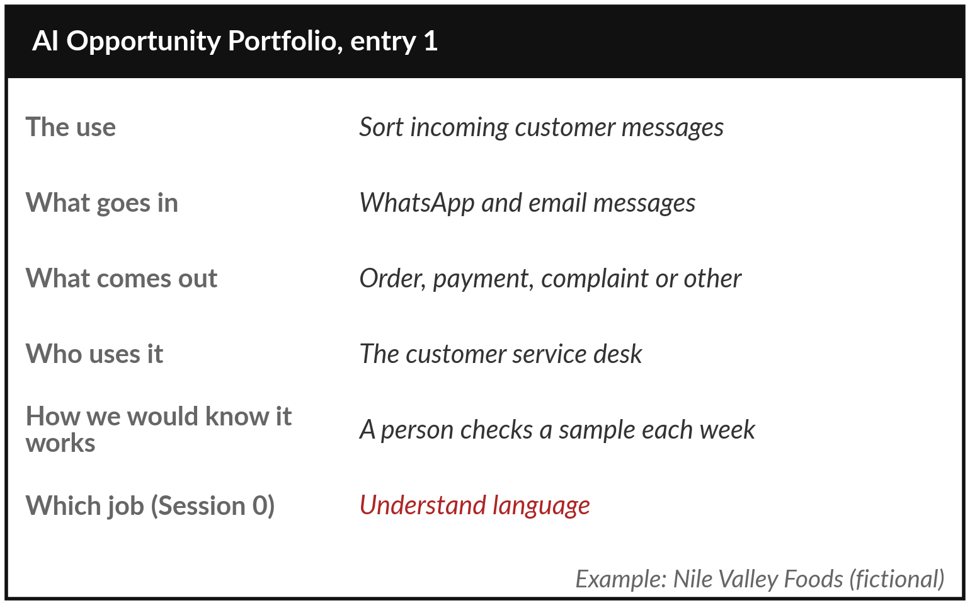
The AI Opportunity Portfolio: one row per possible use, one more column every few sessions.
Template | What it is for | Session
AI Opportunity Portfolio | Your one-page register of possible AI uses. It grows every session and becomes your main take-home. | Every session
Vendor Question List | The questions to put to a supplier, and the answers that should worry you. | 6, 13
Reusable Brief Template | A five-part brief for a team task: role, context, examples, format, constraints. | 7
Reliability Test Record | The count from testing a brief on ten past cases whose answers you know. | 7
Tool Boundary Sheet | What an agent may read, write, send and spend; who approves; the log and the off switch. | 10
Task Card | One task on a card: owner, how often, time today. | 11
Use-Case Scorecard | Several candidate tasks side by side, to choose the one to map first. | 11
Business Case Workbook | Time saved, errors avoided and revenue in shillings: the payback period and the first-year gain. | 11
People and Skills Plan | One role redesigned task by task, skills by level, the fears and your answers, champions and the briefing. | 12
AI Use Policy Template | A one-page acceptable use policy: tools, data, review, owners, incidents, a review date. | 13
Risk Register | Each risk scored for how likely and how bad, with an owner and a control. | 13
Information Inventory | Every data source with its owner, who may see it, and whether it is ready. | 14
90-Day Roadmap | Owners, dates, success measures and check-ins at day 30, 60 and 90. | 14
Your other learner materials
Document | What it is for
Learner Workbook | One page for each session: the steps for the hands-on, the fields to fill in, and your decision.
Take-away Sheets | One page for each session: what to remember and what you keep.
Industry Use-Case Atlas | Every named case of the course and more, grouped by industry: what the AI does, the result, the catch and the source.
Questions to Ask | The questions from every session, for your vendors, your IT and data teams and your board.
The follow-up kit
Item | What it is for
30-60-90 Check-in Form | A one-page form you return at day 30, 60 and 90: what is running, what it saves, what changed.
Results Tracker | The few numbers you record each month for your first AI use.
Sponsor Briefing | A short brief for the senior sponsor of your first 90 days.

The Practice Files folder holds the files of Nile Valley Foods Ltd, the fictional distributor used in the demonstrations: customer messages, sales, supplier invoices and agreements, a staff handbook extract and a vendor proposal. Use them, or invented information, never real personal data.

Part 8
What to prepare
Nothing, except one choice.
There is nothing to read, install or study before the course. In Session 0 you choose your industry: the one you lead in, or the one you most want to understand. Every session from 1 to 10 then gives your industry one use of the day’s idea, and your portfolio fills with uses for your own organisation.
Helpful, if you have a moment
• Think of two or three tasks in your organisation that take many hours, repeat every week, or wait on one person.
• Ask your team three questions, without blame: which AI tools do you already use, for what, and what would help you use them safely?
• Bring a laptop or phone with an AI assistant you already use, if you wish to try the demonstrations. Use invented or sample information only.

Your industry
Write it here, and keep it for the whole course:

Jotham Martin Wambi | KLAi Professional Learning, Kampala | jothammartin.wambi@gmail.com | +256 750 990 718

